Computer Language Coding Concepts

Specialization
In the articles about the main concepts of inheritance it was explained that at its base the concept of inheritance is the same as the concept of interfaces.

However, the extra that comes with inheritance is specialization. There are three groups of specialization techniques. Each will be separately adressed:

Altering the Member Set
Detouring Members
Altering Command Implementations

Author & Copyright: Jan-Joost van Zon Date: May 19, 2010 – May 22, 2010 Location: Oosterhout, The Netherlands Status: Last Review

Altering the Member Set
The easiest group of specialization techniques is altering the members set. Three techniques can be identified:

Member Addition
Member Exclusion
Member Inclusion

Member Addition
The easiest technique for specialization by altering the member set is member addition. Here you have the concept of class inheritance:

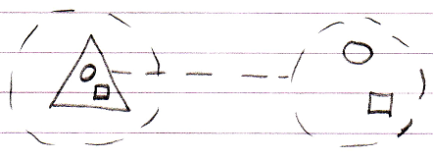

Member addition means adding a member, that was not there in the base, but will be in the derived object:

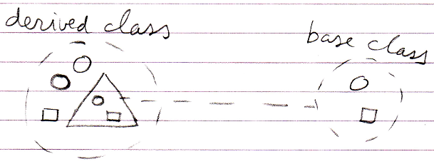

Member Exclusion
Another technique for specialization by altering the member set is member exclusion. This is not possible in most other object oriented languages. What happens is that members from deeper objects that were formerly Public, are Private through the derived class.

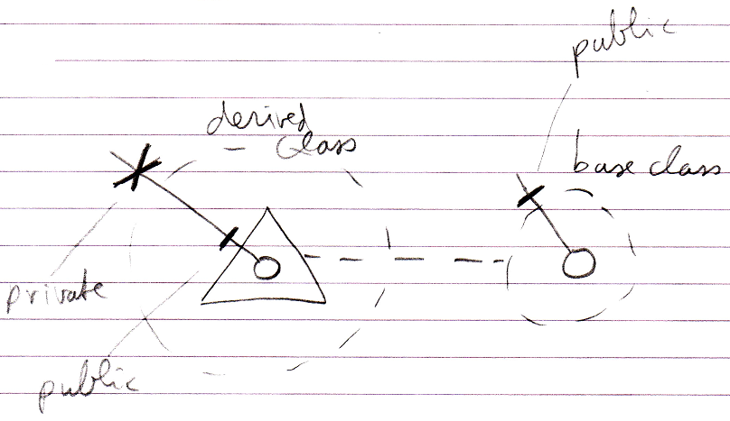

Member Inclusion
Another technique for specialization by altering the member set is member inclusion. This is the opposite of member exclusion. Instead of making a formerly Public member Private, you make a formerly Private member Public. This seems to go agains the rules for encapsulation, but in fact it is valid, since only Friend objects can do it.

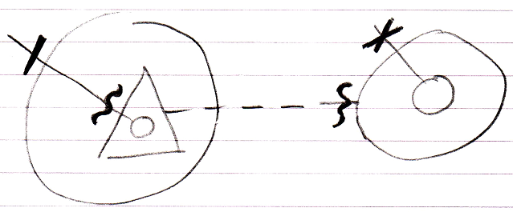

Detouring Members
The second group of specialization techniques is detouring members. This technique allows a derived class to redefine a member from the base class. This can happen in two ways:

Shadowing
Overriding

Disclaimer
Inheritance makes extensive use of the concepts of overriding and shadowing. However, the notations and implementations of overriding and shadowing are not worked out to perfection yet. Preliminary notations are proposed. They will be reconsidered when working out the chapter Object Resolution.

Shadowing
A derived class can shadow a command of the base class. This means that when you call a base command through the derived object, the derived command is run instead.

Below you see a normal base member and a call to it:

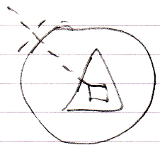

Below you see the situation when the base command is shadowed:

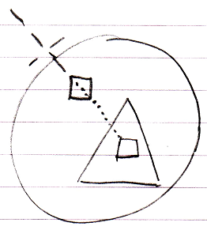

You can still call the base command, by qualifying the call so that the interface is adressed directly:

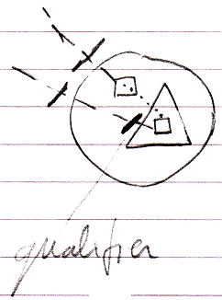

When the base class itself calls the shadowed command, the original base command is called.

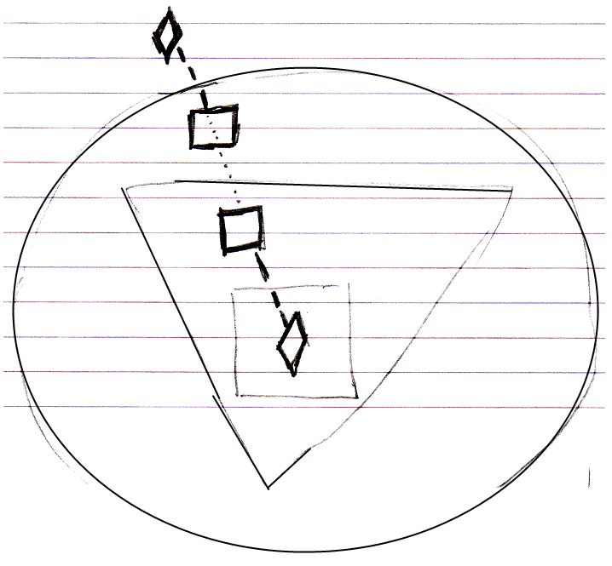

This is where the behavior is different from overriding.

What should be mentioned is that you can also shadow objects, just like you can shadow commands.

Unshadowed:

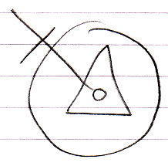

Shadowed:

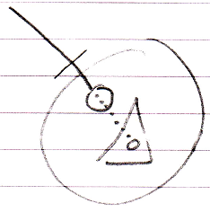

Access base member through qualifier:

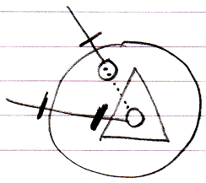

Base class calls base member, not derived member:

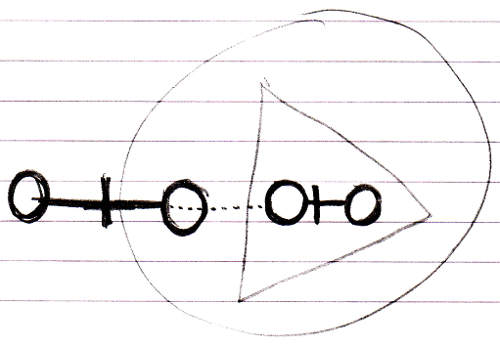

Overriding
Base classes normally call their own commands:

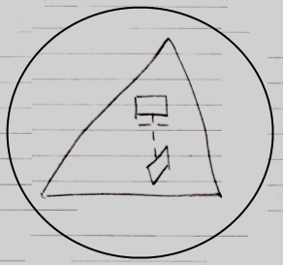

But derived classes can redefine those commands. When the base class tries to call its own command, the call is detoured to the redefined command. In other words: the original call to the command is detoured to another command.

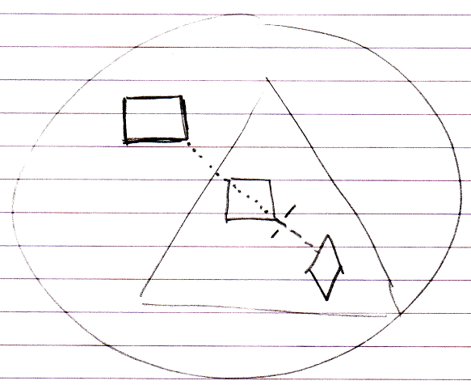

The base class can not run its original command anymore.

One thing that should be mentioned is that in object inheritance, multiple derived objects could redefine the same base command.

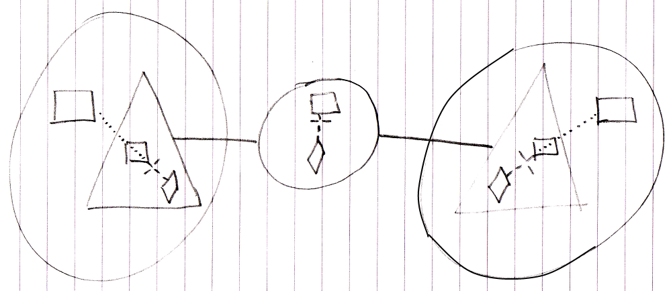

In that case some kind of disambiguation or combining must take place. Probably just all overrides will be run and the base command will not.

What should be mentioned is that you can also override objects, just like you can override commands:

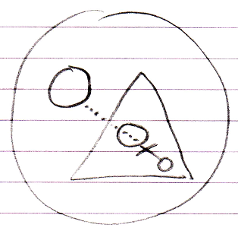

You do not have to show a reference to the object to show that it is overridden. Here is an unreferenced overridden object, which consitutes just the declaration that the object is overridden:

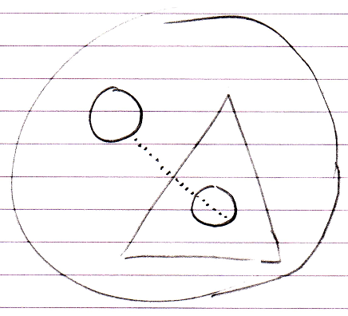

Overriding Alternative: Object Redirection
Later it was figured out that overriding could also be expressed and implemented by means of simple object redirection:

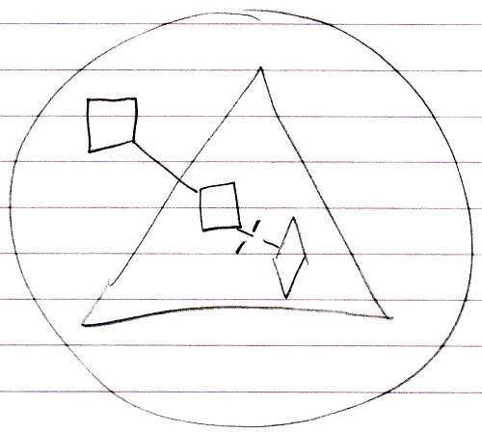

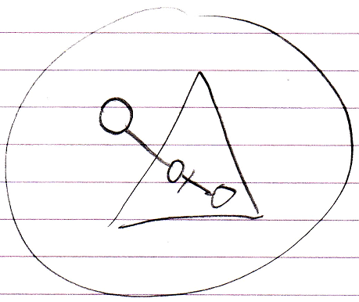

So redirecting an object to another object in the container above it, actually constitutes overriding.

This alternative, however, does not allow multiple overrides in object inheritance. (However, in class inheritance it does.)

For now no decision is being made about which notation or implementation is better.

Overriding Alternative: Event Notation
When trying to find notations for overriding and shadowing system commands, things just could not be figured out.

A simpler alternative to the overriding notation is an event notation. Fortunately, the event notation looks intuitive.

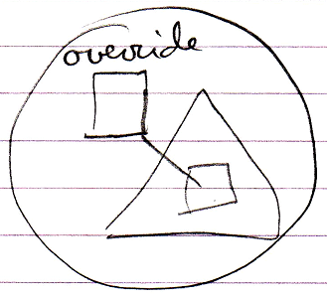

It does not seem to work for object overriding, since events are commands.

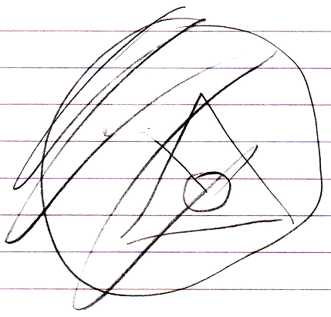

Deficiency: Calling Base Class’s Version of Overridden Member
You can not call the base command anymore if it is overridden. You can not call an overridden base procedure without it being detoured again. For now it is not possible. In other languages it is.

Altering Command Implementations
Another way to specialize a derived object is to alter the command implementations of the base object.

Command Extension
When a base class defines a command, the derived class can add extra functionality to the existing command. The derived class can pre- or post-extend a command from the base class:

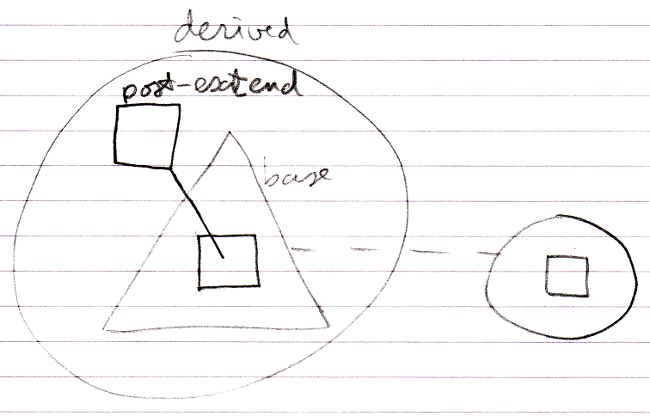

This pre and post-extension happens by means of the already available system events explained in the Events chapter. The events are actually named Executing and Executed.

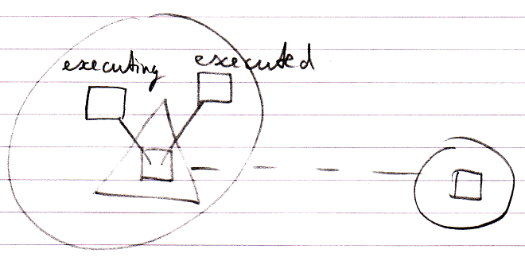

Extending System Commands
Another way to specialize a derived object is to let it define extra functionality around a system command. In the previous section it was already shown how to extend the implementation of the Execute system command. But other system commands can be extended as well, such as the Value Set command. Here is an example where the Value Set command is post-extended by implementing the Value Changed event.

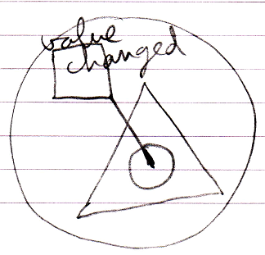

So then the derived class defines something that will be run every time the object’s value changes.

Overriding System Commands
Overriding was already introduced before, but what is separately mentioned here is that you can override any of the system commands. You can for instance override the Value Set command.

An overriding notation based on the connector notation for system commands failed. A lot of notations were considered but many were complicated or ambiguous. Easier alternatives are adopted here as a preliminary notation.

Three alternatives are possible:

The event notation

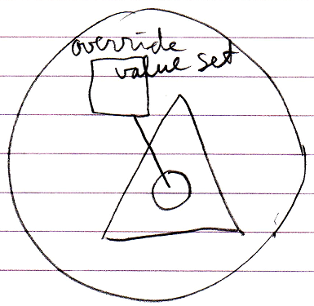

System interface with line extension

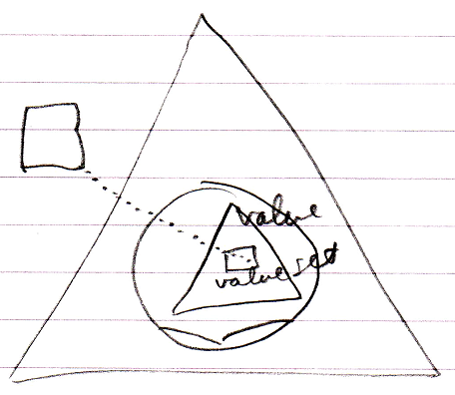

System interface with object redirection

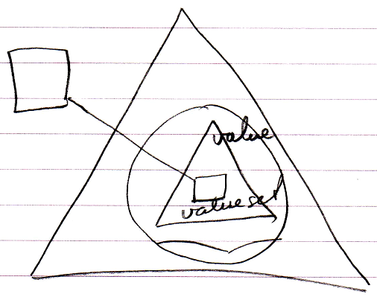

Shadowing System Commands
Unfortunately, shadowing system commands will not be possible yet. You can only shadow the whole object, not a specific aspect of it.

< Maybe if you open the system interface. >

Questionable: Extending System Commands Through Overriding
This is a technique that will probably not work. The idea is that you accomplish command extension by employing the overriding concept. The idea is that you override the base command, executing your own procedure and call the base command from your own procedure.

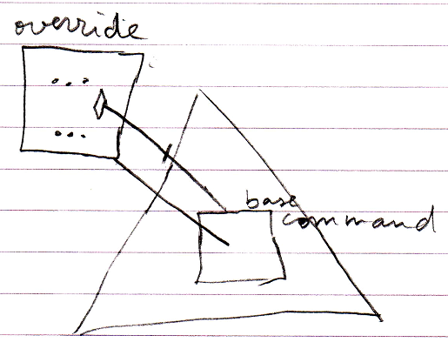

The problem with this technique however, is that the call to the base command immediately detours to the derived command again, causing an infinite loop.

Overriding System Commands Through System Events
There is an alternative to overriding: you can implement the pre-extension event of a command and cancel the event.

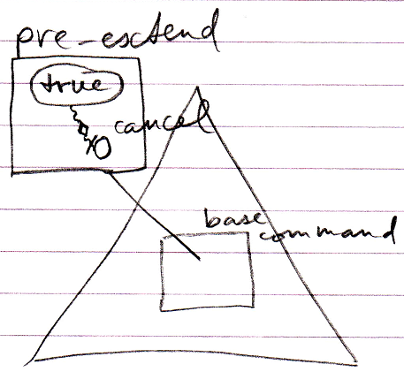

This cancels the execution of the base command.

